Seven Channel MWIR Telescope Design and Image Alignment

Purpose of this document as related to the FSKI definition and design document
The FSKI platform prescribes hexagonal and pentagonal tapered chambers as housings for survey-class telescopic optical equipment including one 7-lens scenario. This document offers a suggested design with actual specific properties designed with Zemax Optic Studio toolsuite. All the design parameters in this document have been included in this real artifact to further confirm the viability and useability of the FSKI platform.

Phase III technical report, 18 October 2026
The telescope combines seven refractive optical channels to cover a larger region of the sky. Each channel forms its own image; the overlapping images are then aligned and blended into one mosaic. This report introduces the single channel design first, followed by the seven channel arrangement, the simulation workflow and the image alignment code.
Based on the updated Phase III requirements, the original Schmidt–Cassegrain configuration has been replaced by a fully refractive optical design operating at a wavelength of 4.4 μm. The single-path system was optimized for a 127 mm entrance pupil, an effective focal length of 635 mm, and a maximum field angle of ±1.75° (3.5° full FOV).
Two versions are presented in this report. The first is an initial design with a total optical length of approximately 901 mm, providing excellent diffraction-limited performance across the full field of view. Based on this design, a second compact configuration was further optimized to reduce the total optical length to approximately 702 mm while maintaining the required focal length, field of view, and high image quality.

Main system properties
Each channel has a 127 mm entrance pupil, approximately 635 mm effective focal length and a 3.5° full field of view at 4.4 μm. The corresponding focal ratio is approximately f/5. The compact design is intended for integration into the seven channel architecture.
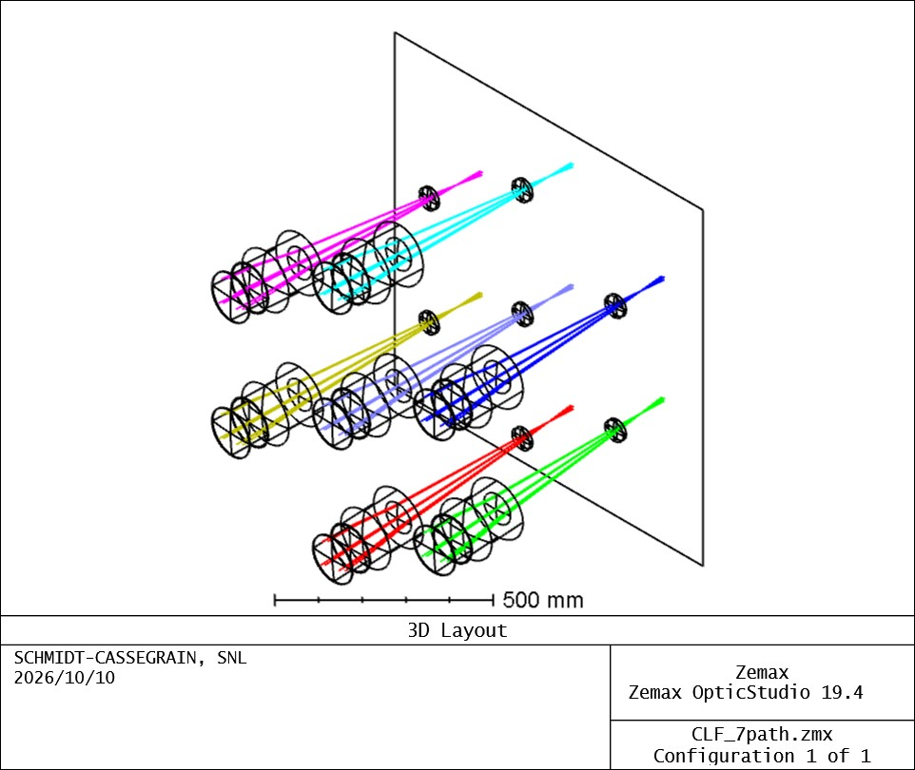
Figure 1 Seven channel optical layout from the existing non sequential model
The purpose of the mosaic is to extend field coverage. Its resolution remains subject to the optical system, detector sampling and alignment accuracy.

1 Initial single channel design
Both refractive designs achieve the main optical targets for the 4.4 μm single-path system. The initial 901 mm configuration provides extremely small RMS spot radii of less than 2.6 μm, with the MTF essentially coinciding with the diffraction limit over the full ±1.75° field.
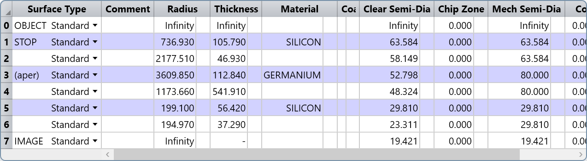
Figure 2 Initial lens data sheet
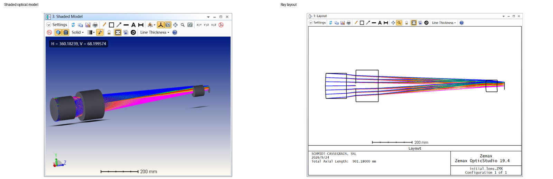
Figure 3 Initial configuration with total optical length approximately 901.18 mm
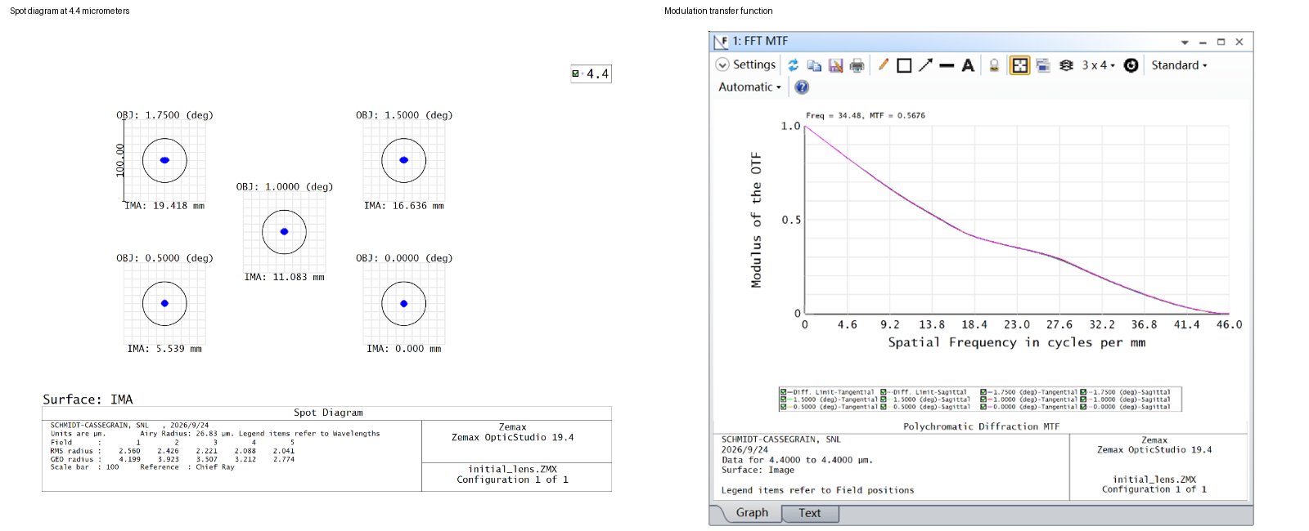
Figure 4 Initial spot diagram and MTF
RMS radius less than 2.6 μm under a 4.4 μm light source. The black circle represents the diffraction limit. The MTF curve coincides with the diffraction limit.

2 Compact single channel design
The compact design reduces the total optical length from approximately 901 mm to 702 mm, corresponding to a reduction of about 22%, while retaining the same 635 mm effective focal length and 3.5° full field of view. Although the RMS spot radius increases slightly to below 8.9 μm, the spots remain well within the diffraction scale and the MTF remains very close to the diffraction limit across the full field.
Therefore, both configurations are suitable for the single-path optical system. The compact 702 mm design provides a more practical geometry for subsequent integration into the 7-channel architecture while preserving near-diffraction-limited optical performance.
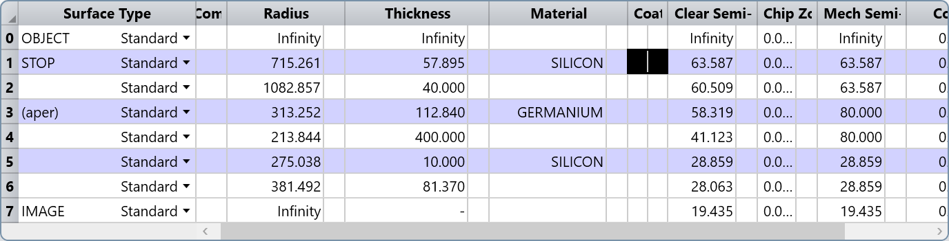
Figure 5 Compact lens data sheet
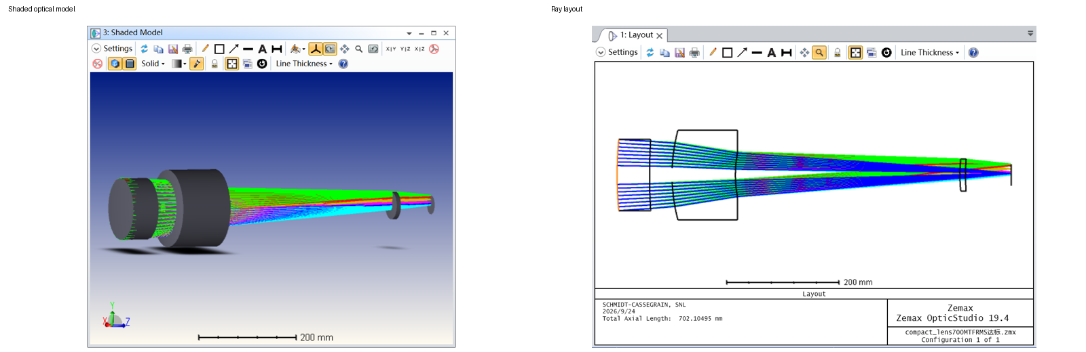
Figure 6 Compact configuration with total optical length approximately 702.11 mm
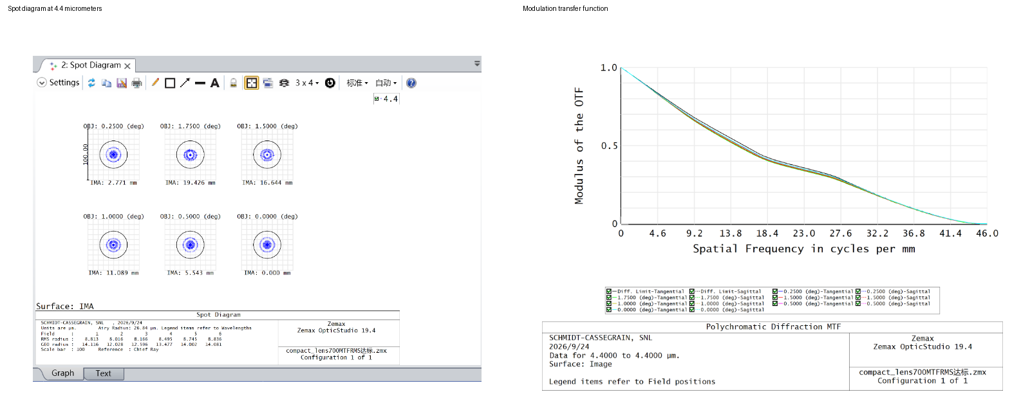
Figure 7 Compact spot diagram and MTF
RMS radius less than 8.9 μm under a 4.4 μm light source. The black circle represents the diffraction limit. These optical model results do not establish the resolution of a sampled detector image.

3 Seven channel geometry and overlap
Channel G is central; channels A to F surround it. The nominal pointing separation between the center and each peripheral channel is 3°. Each circular field has a 3.5° diameter, giving approximately 0.5° overlap along the line between adjacent field centers. This shared sky content is the basis for alignment.
The nominal sky coordinates in degrees are A (0, 3), B (2.598, 1.5), C (2.598, −1.5), D (0, −3), E (−2.598, −1.5), F (−2.598, 1.5) and G (0, 0). In the image convention, positive x points right and positive sky y points up. These coordinates initialize the overlap search; they do not determine the final fitted image positions.
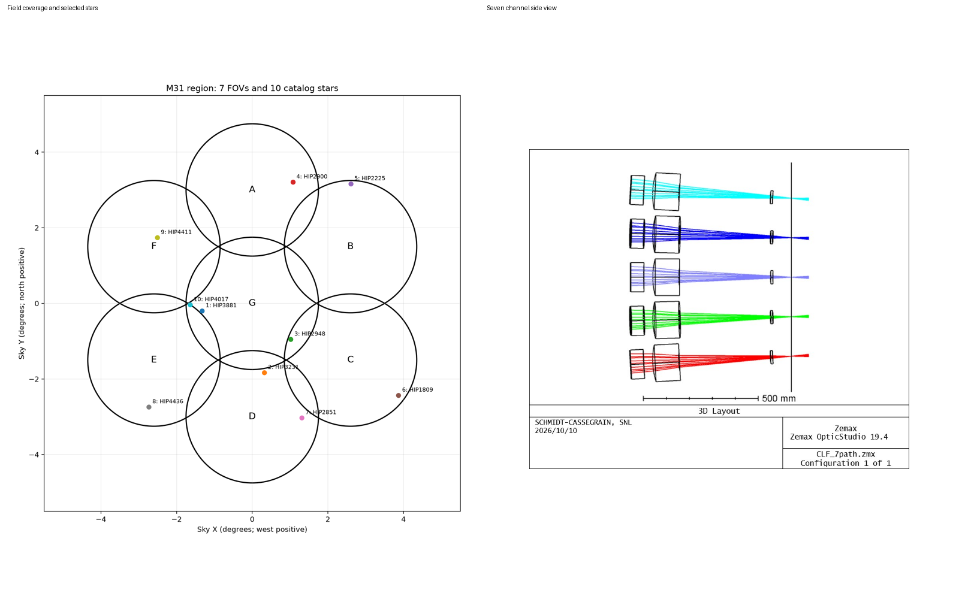
Figure 8 Nominal field coverage and the multi channel optical arrangement
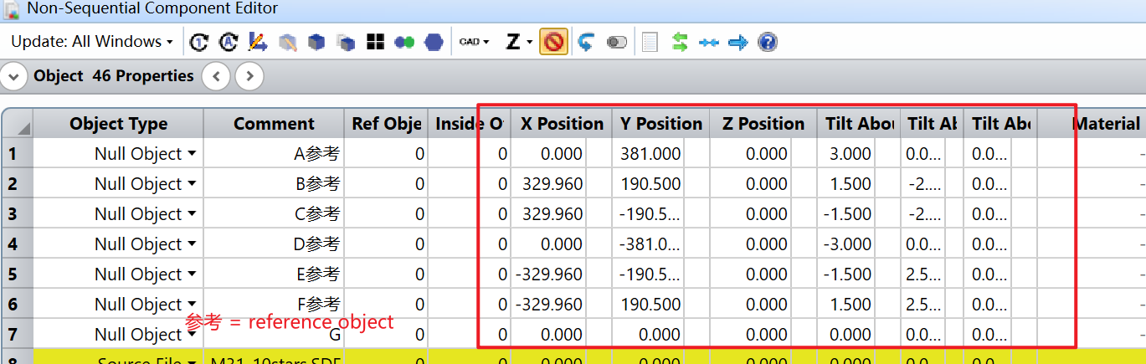
Figure 9 Channel reference objects and positions in the non sequential editor
The ray generation code uses a 381 mm mechanical radius for the peripheral channel centers. The mechanical coordinates and the angular pointing coordinates have different units and roles.

4 Simulation inputs and ray generation
Simulating an image at infinity in non-sequential mode requires an enormous number of rays. Therefore, ten selected stars in M31 were used as references for the simulation. Ray tracing makes the star positions directly visible; a separate image simulation and alignment workflow handles the extended sky image.

The existing star ray generator
generate_star_rays.py queries Hipparcos near M31, selects ten stars and determines which circular fields contain each star. It converts their celestial directions into the Zemax coordinate system and launches parallel ray bundles toward the corresponding telescope apertures. The outputs are M31_10stars.csv, M31_10stars.SDF and the star layout plots.
TOTAL_RAYS = 240000 is divided across the selected star and channel pairs, using a fixed random seed. Each ray has an initial position, direction, relative intensity and wavelength. The configured wavelength is 4.4 μm. The 50 mm launch pupil radius is a debugging beam size, not the 63.5 mm radius implied by the 127 mm optical entrance pupil.
V magnitudes set illustrative relative weights in this script. They are not 4.4 μm stellar photometry, so the generated ray intensities do not validate MWIR radiometry or sensitivity.
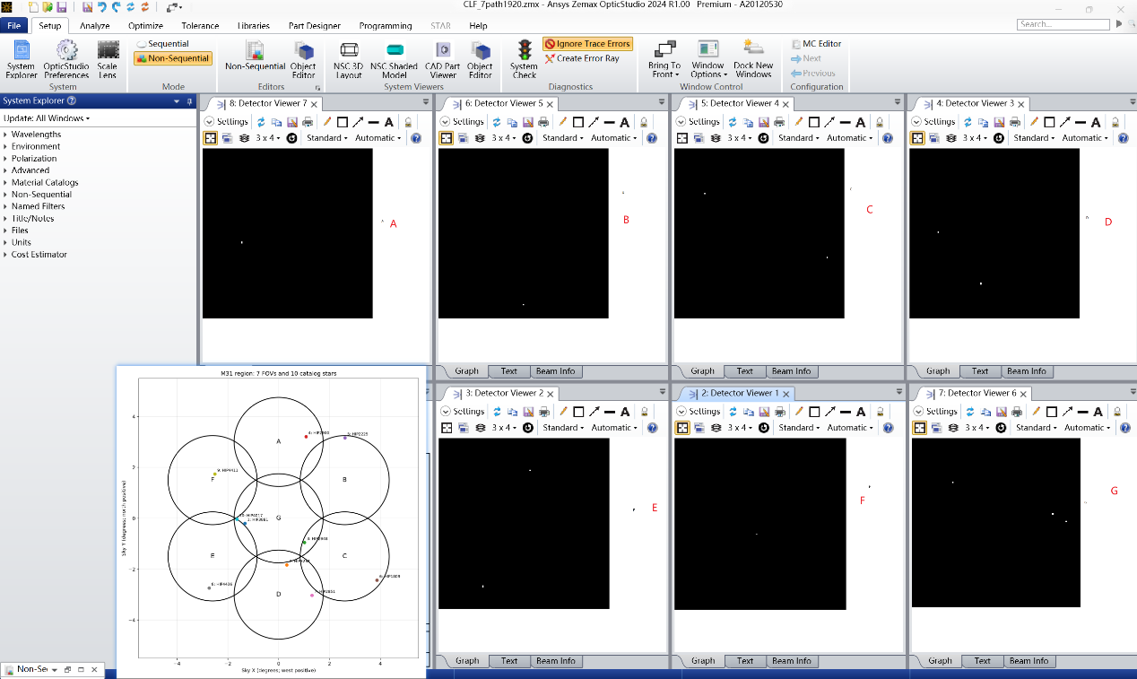
Figure 10 Existing seven detector ray trace display

The sky image and exported bitmaps
The original image was generated using the CDS hips2fits service. Segment.py crops seven circular fields from this image, saves Channel_A.bmp through Channel_G.bmp and places those same crops back at their original positions to create Mosaic.bmp. That earlier mosaic is a coverage demonstration; it does not estimate alignment errors.
The figures show simulated images of M31 for the seven telescope channels. Each image represents the region of the sky viewed by one channel, with some overlap between neighboring channels. The combined mosaic illustrates how these seven views come together to provide a wider field of view.

5 Image alignment from overlapping image content
The new program register_zemax.py measures overlap similarity before composing the mosaic. It uses approximate field geometry to identify candidate neighbors and initialize the search, then estimates each accepted transformation from the actual image content.

Image extraction and pair alignment
zemax_images.py detects the large dark square inside each white export frame and removes the footer. It validates the shape rather than applying fixed crop coordinates. The current images have the same orientation as their source bitmaps; orientation changes can be specified separately for new detector exports.
registration.py resamples each field to a 652 × 652 working grid, forms a grayscale high-pass signal and masks out the circular boundary. A coarse translation search starts several ECC affine alignment runs in the predicted overlap. The affine transform can correct small translation, rotation, scale and shear errors. Alignment uses the image signal; output colors are preserved .
Zero mean normalized cross correlation measures similarity over valid shared pixels: NCC = Σ[(I − mean I)(J − mean J)] / √{Σ(I − mean I)² Σ(J − mean J)²}. By default, a candidate must reach NCC ≥ 0.45 with at least 500 overlap pixels. Implausible transforms and competing, nearly equal solutions are rejected.

Global alignment and blending
Accepted pair transforms form a graph anchored to channel G. A robust least squares fit estimates one affine transform per channel, using all accepted overlap constraints. Inconsistent loops are removed, and the fitted overlaps are checked again. If any channel becomes disconnected or the global checks fail, the program stops without producing a mosaic.
The fitted images and their masks are warped onto one canvas. Circular edge weights are normalized in overlapping areas so that images blend instead of overwriting one another. The output contains the mosaic, a transparency mask, a coverage map and a manifest recording every crop, transform, similarity score and rejected pair.
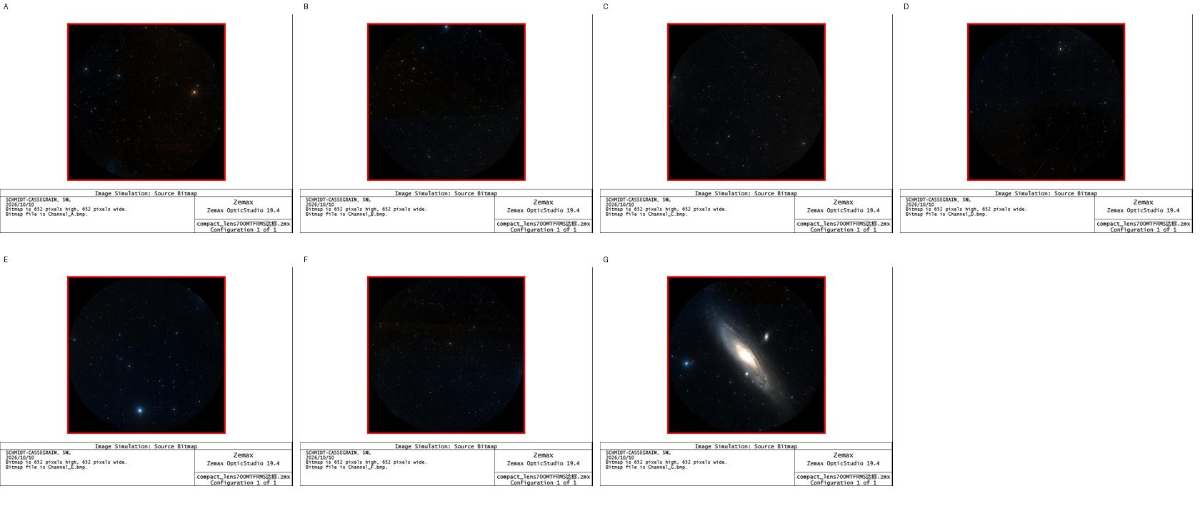
Figure 11 Automatically detected image regions in the seven framed exports

6 Aligned mosaic and verification
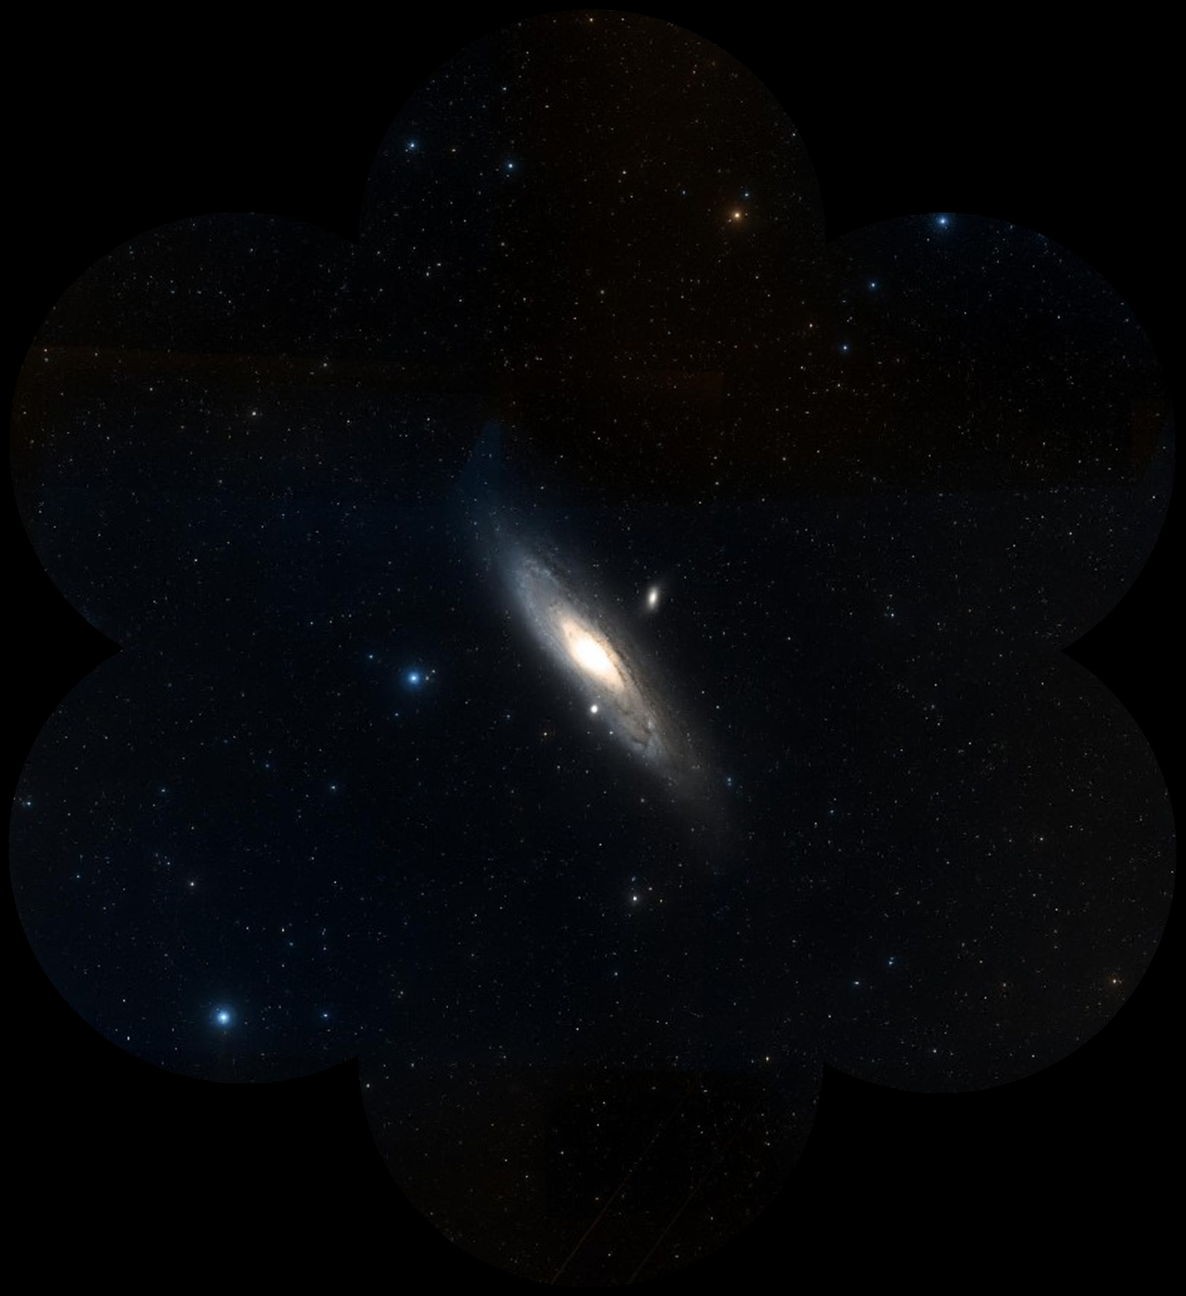
Figure 12 Combined mosaic of the seven simulated channel images
The 10 overlap regions with the highest image similarity were selected from 12 candidates and used to align the seven channel images. Their mean NCC increased from 0.584 before alignment to 0.691 after alignment.
The error recovery test adds independent translations up to 4 pixels, rotations up to 0.5° and scale changes up to 0.2% to the existing fields. The algorithm realigned the images after small shifts, rotations and scale changes were introduced in the test. The remaining position error was about 1.0–2.3 pixels, measured on images of 652 × 652 pixels.
The current method assumes modest alignment errors and a locally affine mapping. Strong lens distortion, large pointing errors, different point spread functions, sparse stars or low signal can require calibrated distortion correction and astrometric alignment.

The enlarged views below compare two sky regions in the original image, a direct overlap and the aligned mosaic.
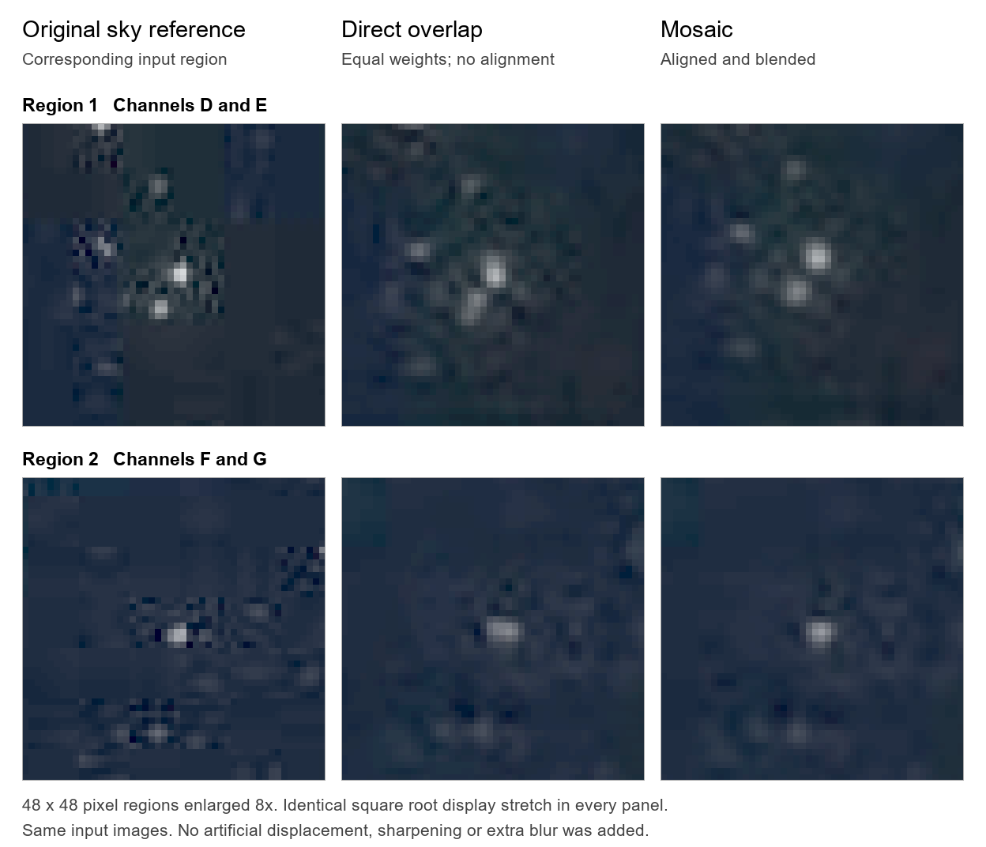
Figure 13 Local comparison of the original image direct overlap and aligned mosaic

7 Resolution and detector considerations

Optical resolution and field coverage
The 0.91 arcsec requirement no longer applies. To achieve the largest combined field of view, the algorithm will not further improve the original resolution.
For a circular unobstructed 127 mm pupil at 4.4 μm, the Rayleigh estimate is θ = 1.22λ / D ≈ 8.7 arcsec. At a 635 mm focal length, the corresponding Airy radius is approximately 26.8 μm.

Detector dimensions and sampling
The current non-sequential simulation uses a 22 × 22 mm detector with 256 × 256 pixels. However, the final selection still needs to be confirmed after the algorithm is completed.
At a focal length of 635 mm, the 3.5° full field produces an image circle approximately 38.8 mm in diameter. A square detector would therefore need an active area of approximately 38.8 × 38.8 mm to cover the full field.
For the f/5 optical system at 4.4 μm, Nyquist sampling requires a pixel pitch of about 11 μm or smaller to avoid undersampling the diffraction-limited image.

MWIR detector options
Detector selection should prioritize a pixel pitch of 11 μm or smaller and sensitivity at 4.4 μm. One available option is the SCD Mini Blackbird 1280 HFM, which has 1280 × 1024 pixels, a 10 μm pitch and a spectral range of 3.6–4.9 μm.
Its active area is approximately 12.8 × 10.24 mm, which is smaller than the 38.8 mm image circle of each telescope channel. If a suitable single detector cannot cover the full field, multiple detectors could be arranged to capture different parts of the image plane, with their images subsequently aligned and combined. This would require a dedicated detector mounting and optical arrangement.

8 CAD export and further deliverables

Geometry and ray paths
Zemax supports exporting optical components in STEP, IGES, SAT, and STL formats.
STEP is widely used for exchanging 3D CAD models, including solid geometry.
IGES is commonly used for exchanging surfaces and curves between CAD programs.
SAT is a CAD format based on the ACIS geometric modeling system.
STL represents objects as triangular surface meshes and is commonly used for 3D printing.
For this project, STEP, IGES, and SAT can also include ray paths represented as 3D lines. STL does not support these ray paths.
The ray paths exported from Zemax Non-Sequential Mode are lines rather than solid light cones.
These export capabilities should be checked in the installed OpticStudio version and export settings before delivery. The exported geometry is not a substitute for the optical model and its materials, coatings, source definitions or detector settings.
Rays can be exported, but not as light cones; only wireframes can be exported. Printable light cones require additional solid modeling from the ray geometry. STL is suitable for printable mesh geometry; it cannot store wireframe ray trajectories.

High ray count files
The software controls the ray count, and I can export the number of rays you need. Either option is possible: showing only the main imaging rays or including other ray paths.
For the requested high ray count delivery, distinguish the number of source or analysis rays from the layout rays displayed and the trajectories actually written to the exported file. Increasing TOTAL_RAYS regenerates the SDF source file; it does not by itself change every ray display, trace or export setting inside a .zmx model. The two intended models and their export settings must be checked in OpticStudio before delivery.

